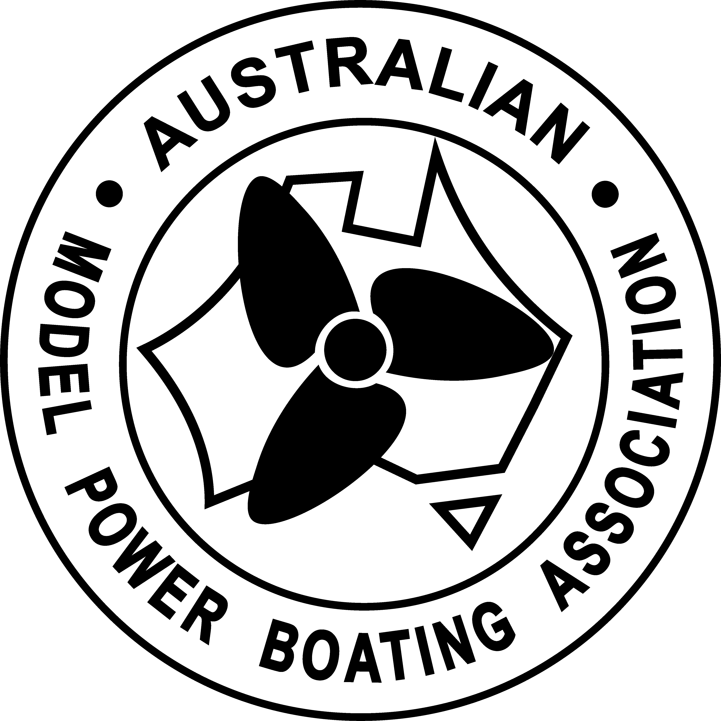
THE AUSTRALIAN MODEL
POWER BOAT ASSOCIATION

POSTAL/EMAIL VOTE FORM 2022

Return this page to the returning officer, by email to secretaryampba@gmail.com or by mail to AMPBA Secretary, 112 Leo Lindo Drive, Shailer park Qld 4128.

Must be received or post marked by 8/5/2022 to be valid

There are two AMPBA Executive positions for general committee, please indicate your vote with an X in the appropriate boxes.

I …………………………………………………………………………………………………… (Please print clearly)
Being a member of the A.M.P.B.A. Inc., hereby register my vote for the following positions.

Membership No. ………………….

Signature ……………………………………………………………. Date……………………………….

Position – General committee (There are 2 only positions avail. Place an x for 2 only names)

Evan Holborow

Bryan Ruttley

Kevin Morris
Frank Jones

